**Assignment 1, Level-5**

**#For getting summary of the dataset, simply use summary function.**

**summary(titanic_data)**

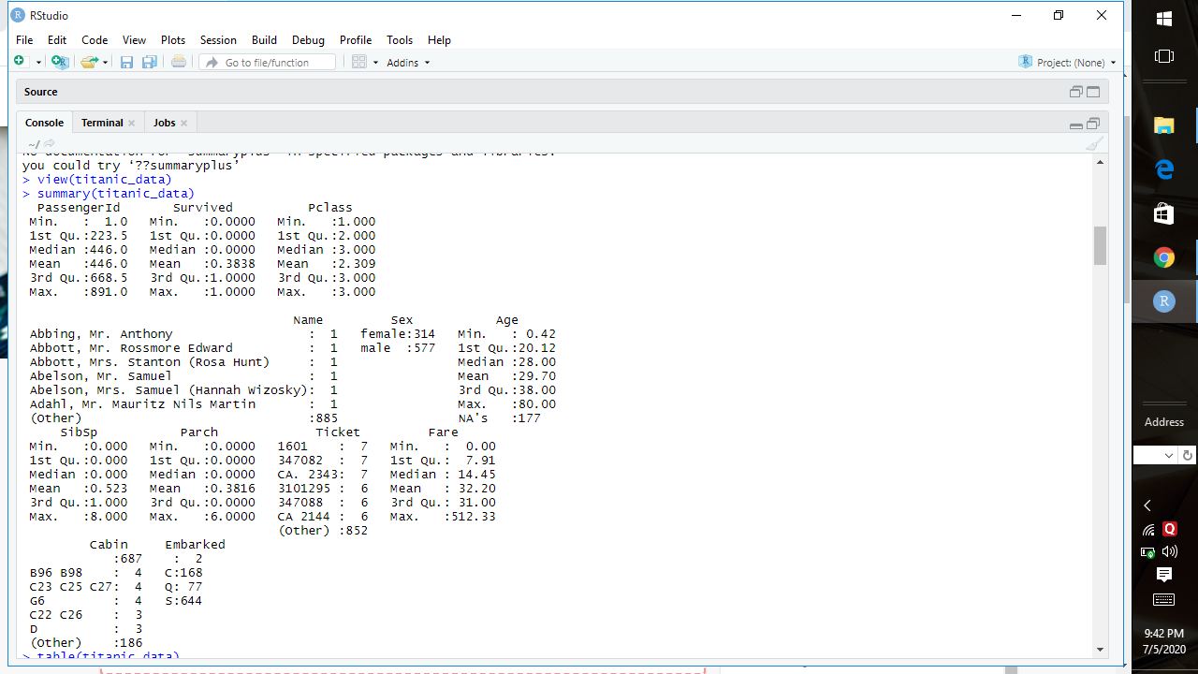

**#For getting the mode, use table function for all the columns individually.**

**#Example-**

**table(titanic_data$Survived)**

**table(titanic_data$PassengerId)**

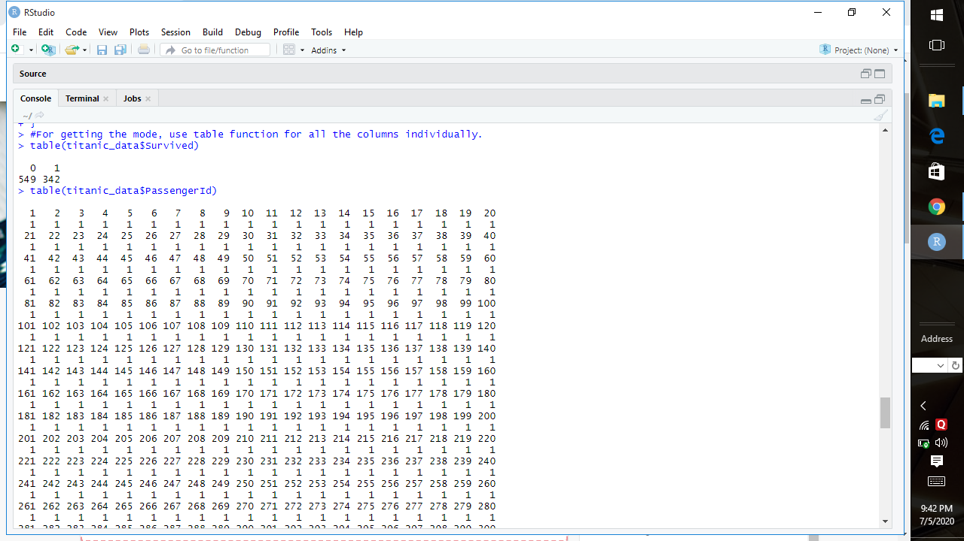

**#If we want to apply all the functions for summary statistics more in detailed way(including kurtosis&Skewness) individually, lets make a function for that!!**

**summaryplus <- function(x) {**

**m <- mean(x)**

**l <- length(x)**

**stnd <- sd(x)**

**variance <- var(x)**

**iq <- IQR(x)**

**rn <- range(x)**

**skewness <- sum((x-m)^3/stnd^3)/l**

**kurtosis <- sum((x-m)^4/stnd^4)/l - 3**

**return(c(Mean=m, Length=l, Standard_dev=stnd, Variance=variance, IQR=iq, Range=rn, Table=t, Skewness=skewness, Kurtosis=kurtosis))**

**}**

**#Example-**

**summaryplus(titanic_data$Survived)**

